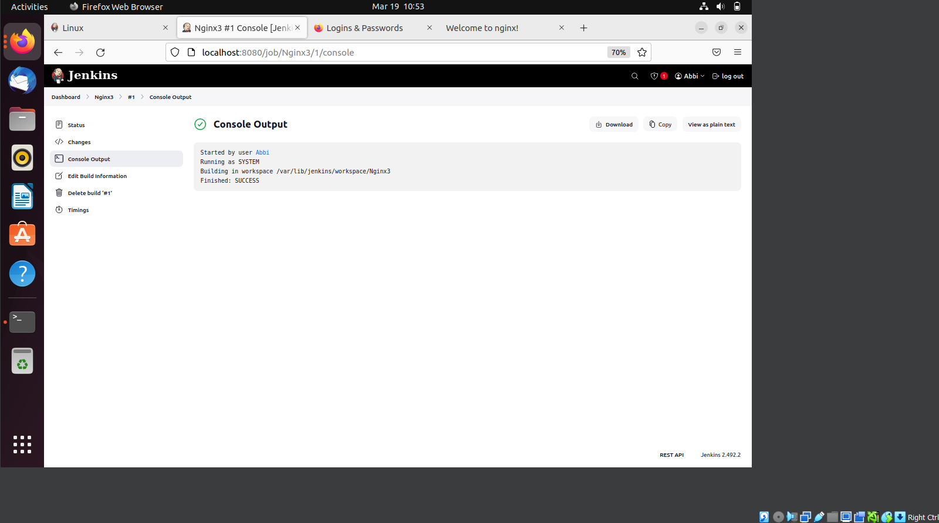

**TASK 1**

**Step 1:**

Open Jenkins and click

**"New Item."**

**Step 2:**

Enter a project name and select

**"Freestyle Project,"**

then click

**OK.**

**Step 3:**

In the

**General**

tab, scroll down to the

**"Build"**

section.

**Step 4:**

Click

**"Add build step" → "Execute shell."**

**Step 5:**

Enter your shell commands in the provided text box.

**Step 6:**

Click

**"Save"**

to apply the changes.

**Step 7:**

On the project page, click

**"Build Now"**

to start the job.

**Step 8:**

The build status will appear in the

**Build History**

(

left

-

side panel).

**Step 9:**

Click on the latest build (#1, #2, etc.) and select

**"Console Output"**

to view logs and results.

**Command**

**:**

#!/bin/bash

sudo apt update

sudo apt install

-

y nginx

sudo systemctl start nginx

sudo systemctl enable nginx

echo "Nginx installation

completed!"